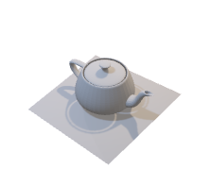INTERVIEW TEST

Develop a algorithm for splitting this model into multiple pieces:

1. Input data: teapot.obj file. This is a 3D sample with .obj format

1. Output: Split the model to 4 pieces like below

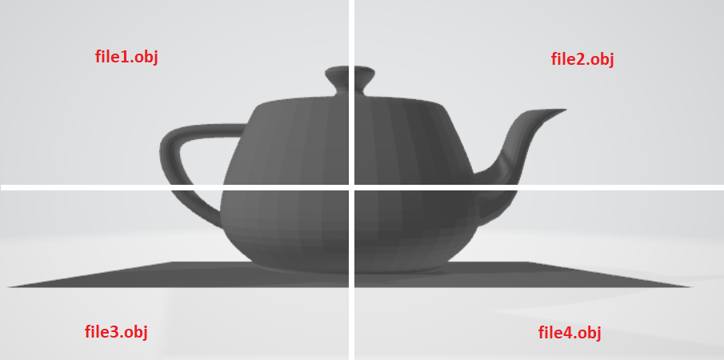

**Answer**

1. **Intuition**

* To split the 3D object into 4 parts, the algorithm can recursively split the 3D object in half (2 times).
* To split the 3D object in half, the algorithm separates the set of vertices and the set of faces in the following manner:
  + Split the set of vertices into two sub-sets: one above the slicing plane and another below the slicing plane. Vertices that are on the slicing plane are added to both subsets.
  + Split the set of faces into two sub-sets: one above the slicing plane another below the slicing plane. Faces that are coincident to the plane are added into both subsets. Faces that cross the slicing plan are deviced into sub-faces that locate on both sides of the sliding plan.

1. **Code Implementation**

Github Repository: [Link](https://github.com/DeCuuTranVo/TeaPot3D/tree/master/TeaPot3D_Algorithms)

Sample input and output files can be found in:

1. **Result illustration**